An all-John Adams evening with the Attacca Quartet at (Le) Poisson Rouge

By Kay Kempin

March 30, 2013

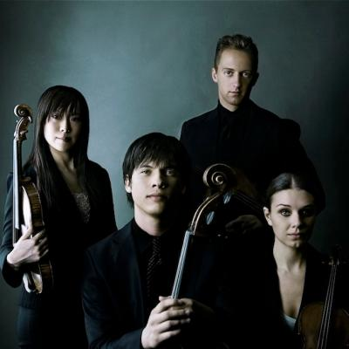

(Le) Poisson Rouge is always an exciting venue for classical music, but to have John Adams in the house Tuesday night was a real treat.

The Attacca Quartet, comprised of violinists Amy Schroeder and Keiko Tokunaga, violist Luke Fleming and cellist Andrew Yee, began the concert with absolutely no pretenses. Playing selections from John’s Book of Alleged Dances, a composition by John Adams for string quartet and recorded prepared piano – and originally commissioned and premièred by the Kronos Quartet back in 1994 – was perfectly suited to this young group. “Rag the Bone”, a catchy, sprightly piece, got us all in the mood. But for what exactly, no one could be entirely sure.

As the quartet traveled through selections of the Alleged Dances, the atmosphere at (Le) Poisson Rouge changed – and it changed drastically, several times. For instance, in “Dogjam”, what Adams referred to as “deconstructed hillbilly”, was humourous and lighthearted. Schroeder (violin), once she started with the melody, never stopped, until halfway through the piece when she passed the frantic melody onto Fleming (viola). All the while, Tokunaga (violin) and Yee (cello) sat there plucking away at their instruments, mimicking the water droplet sounds coming from the recorded prepared piano.

Next up was “Alligator Escalator”, a piece inspired by shoppers traveling up and down the elevator at Macy’s department store in New York. Unlike the brightness of “Dogjam”, this piece was dominated by soft, high-pitched runs that also had a brassy, wirey quality to them, just like an elevator. And the green lighting behind the quartet was clever, alluding to the alligator character in the piece. With a lot of repeated lines, the quartet never faltered – they ended with a chromatic downward spiral in unison, as if our protagonist, the alligator, suddenly jumped off the down elevator and exited the store.

Then the Attacca Quartet performed “Pavane: She’s So Fine”. Just like a traditional pavane, which is a slow, melodious dance, Adams’ piece opened with a quiet and sweet melody high up in the viola with rich undertones in the other voices. Trailing and melodious throughout, the piece felt strangely calm (a contrast to the previous piece) until the end when there was a sudden dark and loud outburst. What looked and sounded like an attack on the strings, it was nonetheless great to see the cellist play so high up on his strings.

A truly expressive player, Andrew Yee made incredible faces throughout the evening. If you were ever in doubt as to the mood of each dance, all one had to do was look up at him to see if the piece was dramatic, humorous, romantic or just plain schizophrenic (Adams’ words himself!).

John’s Book of Alleged Dances is the perfect title for this collection of dances – each piece was driven by a syncopated, percussive beat (the prepared piano), and you could see feet tapping across the hall.

Performing Adams’ String Quartet in the last half – what Adams called a “real string quartet” – the abstract title refers to the asymmetrical nature of the piece. The first part felt like a modern experiment: with no single melody carrying the piece, a layering of rich harmonies instead drove the musicians. The effect was enchanting, until we were suddenly pulled out of our dreamlike state with a violent scherzo, what Adams referred to as “Schoenberg on acid”. With a soft grey backdrop, and the musicians dressed in black, white and a bit of sparkle, the whole first half felt like a clip from a tragic black-and-white film.

Very unlike the first section, part two of the String Quartet was more in line with the spirit of the Alleged Dances. Bright and fast, the musical lines jumped around, over and under each other in a playful manner, ending the evening on a high note. Plus, it was a real treat to see the violist play so high up on his bow – on the C string!

Just after intermission, John Adams hopped up on stage and admitted that the first string quartet he wrote was a “real crash and burn”. But honestly, I have trouble believing that after seeing the Attacca Quartet’s incredible performance of his music. Three cheers to them for capturing the multiplicity of personalities embedded in Adams’ music, which is all part of his charm as a modern composer.

